Project Design Phase
Solution Architecture

Date | 27 June 2026
Team ID
Project Name | UCAB – Online Cab Booking System
Maximum Marks | 4 Marks

Solution Architecture:

The UCAB – Online Cab Booking System is a web-based application developed using the MERN Stack. The system provides separate modules for Users, Drivers, and Administrators. Users can register, log in, book cabs, track bookings, and make payments. Drivers can accept rides, update ride status, and share their live location. Administrators can manage users, drivers, and bookings through an admin dashboard. The backend communicates with the MongoDB database using REST APIs, while Socket.IO provides real-time ride updates and Google Maps API enables live location tracking.
Example - Solution Architecture Diagram:

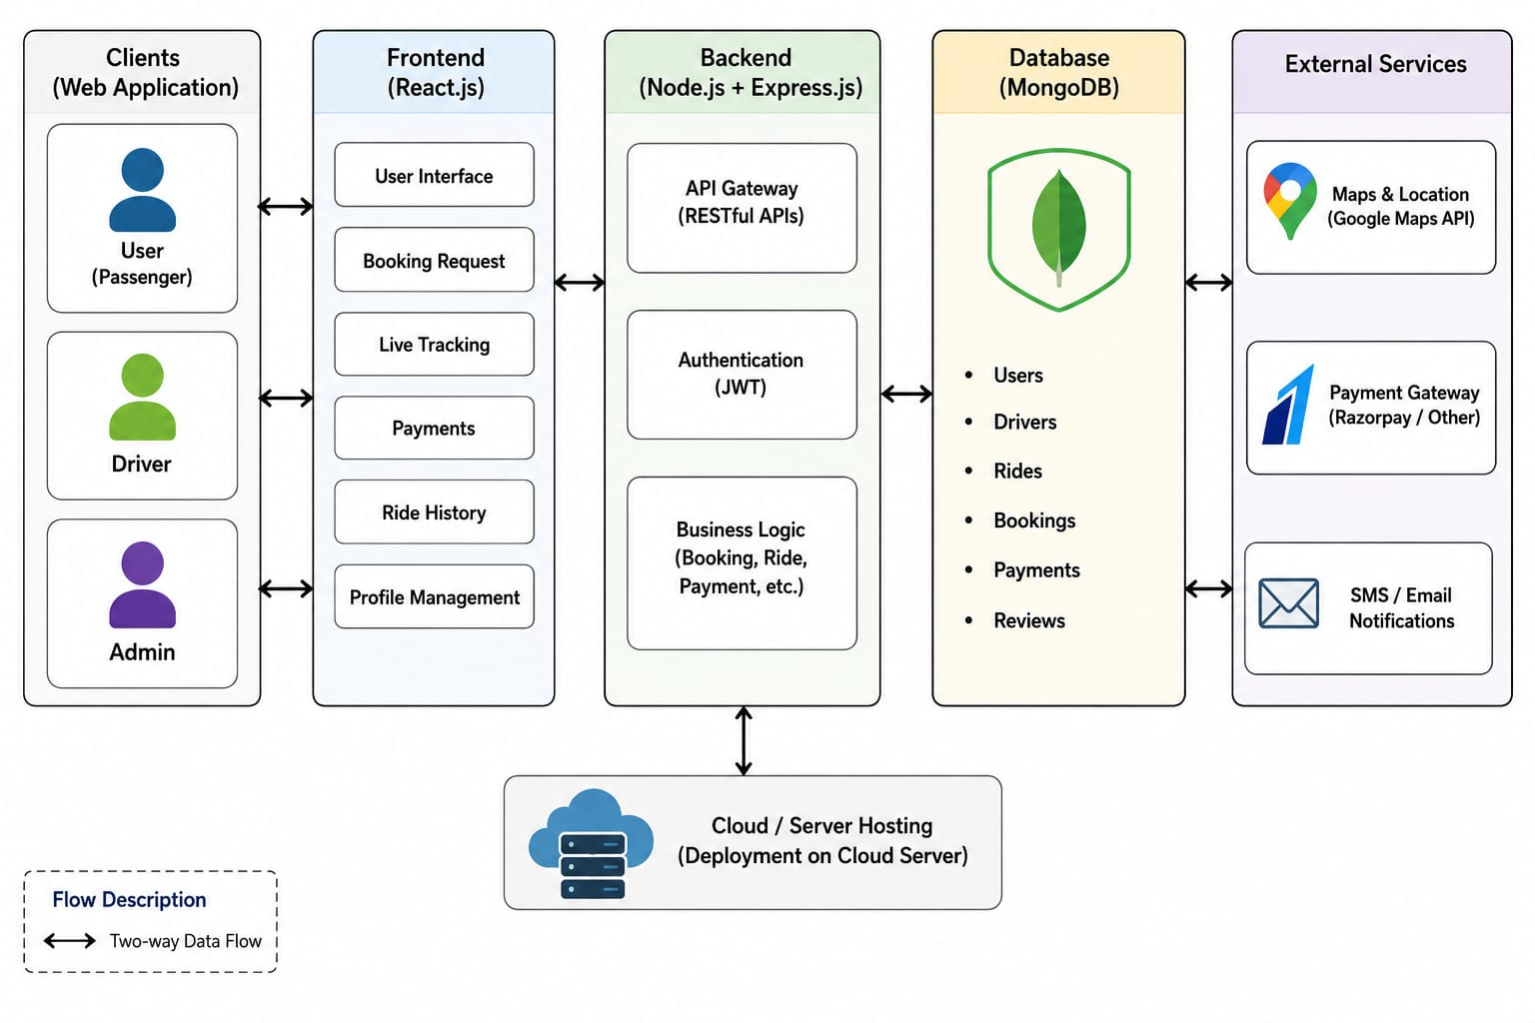

Technologies Used :

Frontend: React.js, Bootstrap

Backend: Node.js, Express.js

Database: MongoDB

Authentication: JWT & bcrypt

Real-Time Communication: Socket.IO

Maps: Google Maps API

Version Control: Git & GitHub

